Creating an Online Ticket

Connect to the Help Desk homepage via https://webhelpdesk.rsccd.edu/helpdesk/WebObjects/Helpdesk.woa
- Sign in using your Network (WebAdvisor) login ID and password
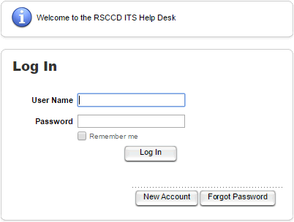

- Select New Ticket
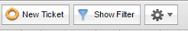

- Enter your First or Last name into the designated area.

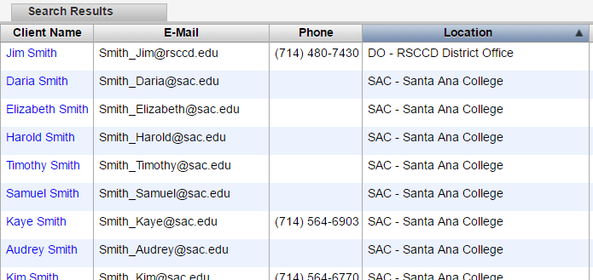
- After you hit the Search button and select your name.

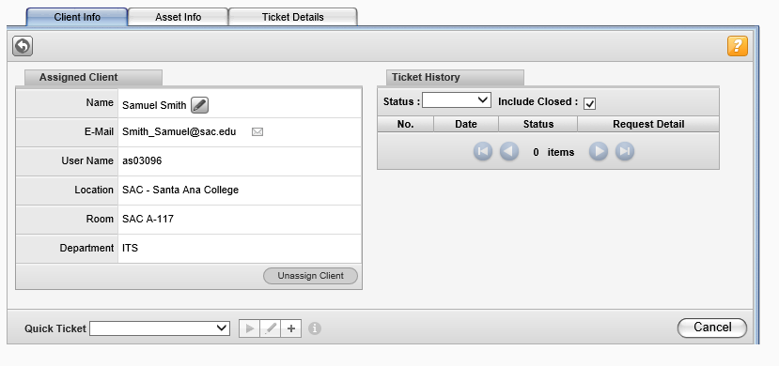
- Verify your information is correct and select the Ticket Details tab.

- Use the pull down menu to submit the Request Type. Depending on your request there will be a second pull down menu to help us narrow down the issue.
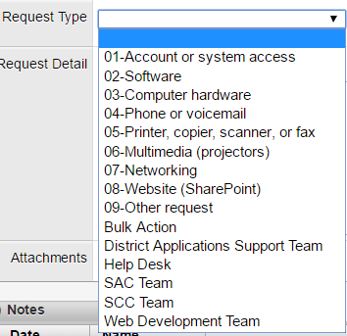

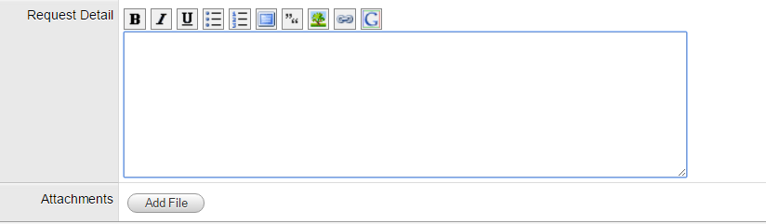
- After the Request Type is entered, please explain the issues you are experiencing in as much detail as possible. Also, if you are able to take a screenshot of any errors you receive you can add a file.

- After you finished entering in the details then click Save & E-Mail and it will be assigned to a technician by Help Desk.
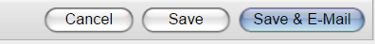

Written by: Samuel Smith

