

Under the RSCCD Microsoft license agreement, faculty and staff are qualified to use **Microsoft E-Learning**, which is an online trainning environment filled with valuable resources (at no additional cost).

Employees are eligible to access E-Learning courses online at Microsoft.com. These courses are meant to help you keep up-to-date with the latest major software releases. Access to the Microsoft E-Learning online environment is for employees of **SAC, SCC, and DO only; your access will be terminated immediately if/when your employment ends.**

**Do not share the codes below with unauthorized users;** this is not permitted under our license agreement with Microsoft.

To login to the Microsoft® E-Learning courses, please follow the steps below:

1. Go to: <https://onlinelearning.microsoft.com/subscriptionactivation/> and select “**Office 365 account**” and login with your email and network password.

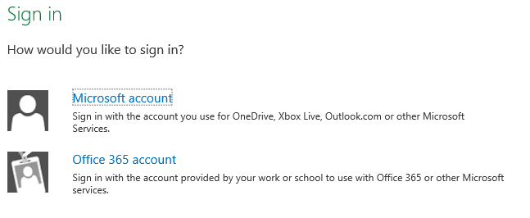

2. Enter your multiuse access code shown below (the code is case-sensitive) and your work email address:

**Our SAC, CEC, and DO Program Code is: IWO34CD193** 🡨 Maximum of 893 users **Our SCC and OEC Program Code is: IWOC0EB0CF** 🡨 Maximum of 400 users

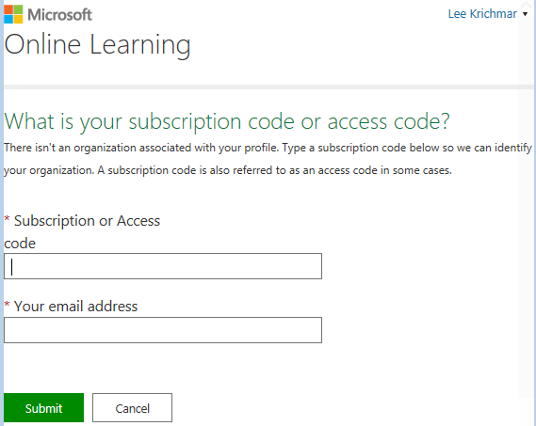

4. You’ll be prompted to complete your profile and click “Save” as shown below:

[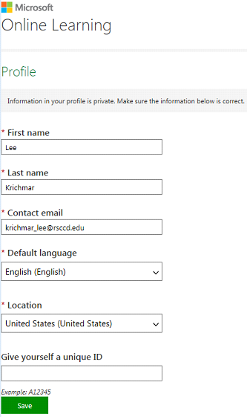](https://onlinelearning.microsoft.com/PrivacyAcceptance/EulaAcceptance?whr=urn:federation:MicrosoftOnline&mode=1)

5. You will receive an e-mail confirming your registration. A confirmation page appears indicating that the access code has been accepted (or you may receive an error message if the code was not accepted). You will need to “Accept” the license agreement to proceed.

6. Once logged in, you can use the search window to find topics of interest; click the “Add” button to add any specific course to your course list.

7. Click a course title to launch the training. You have 12 months from the time of launch to finish that course.

**Once registered, to access your course at any time, please follow these steps:**

1. Go to: <https://onlinelearning.microsoft.com/>.

2. Click the "Sign In" button, select “**Office 365** **account**”, and login with your email and network password.

3. You can use the search window to find topics of interest, for example, Office 2013, as shown below. Click the “Add” button to add it to your course list.

[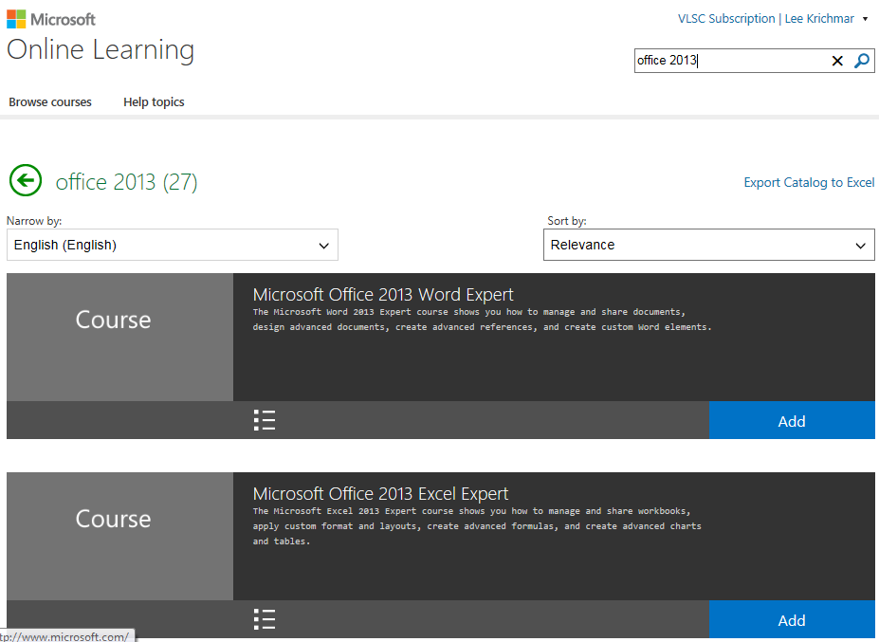](https://onlinelearning.microsoft.com/?whr=urn:federation:MicrosoftOnline)

If you have any questions regarding your access code, or logging into the Microsoft E-Learning site, please contact the ITS Help desk at 564-4357 (HELP).

If you experience any problems with your E-Learning training, please contact the regional support center in your region at <http://www.microsoft.com/learning/support/worldsites.mspx>.

**Do not share the code with unauthorized users;** this is not permitted under our license agreement with Microsoft.